Inside-Out Made Eassy
Walt Wager
Inside-out ornaments are typically made by using 4 rectangular blanks that are glued together, then separated and glued back together so that the outside shape can be turned revealing the inside shape. This is a tedious and exacting process with uncertain outcomes. This article presents a way to get the inside-out look without all the gluing and regluing. You might call it an Inside-Out Illusion.
The project starts with a blank that is at least 2” x 2” x 3.5” long.

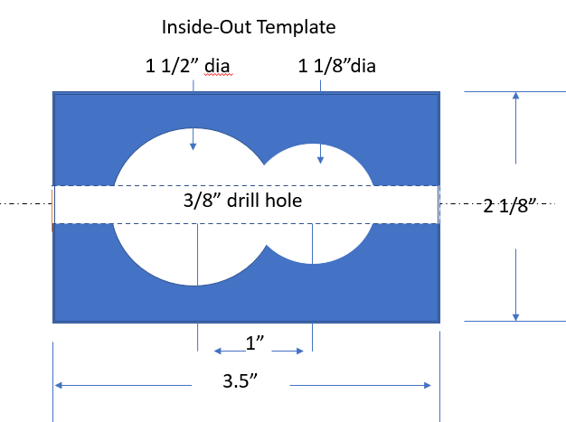
Layout - Carefully measure and connect the lines for the Forstner bit holes around the blank using a square. This is important because the better the holes are aligned, the smoother the inside will be.
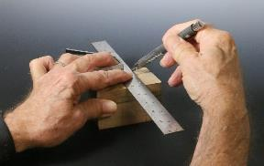 | 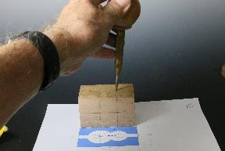

Use a center punch to mark the center of the holes to be drilled with a Forstner bit (photo 2). Secure the blank in a drill vise or clamp it to the drill table. (Do not try to hold the blank with your hands). I drill the smaller hole (1 1/8”) first because it makes it easier to drill the larger hole later (photo 3).
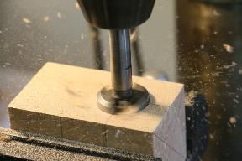 | 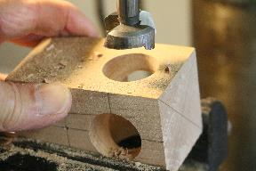

Drill at least ½ way through the blank. Rotate the blank 180 degrees and drill the next small hole, meeting up with the other side (photo 4). The more accurate the better. Rotate it and do the same for the remaining 2 sides. Now install the larger (1 ½”) Forstner bit and drill the holes (photo 6 and 7).
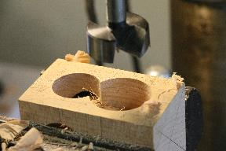 | 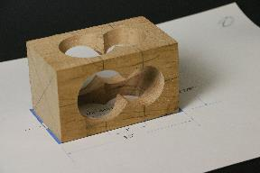

If the inside needs sanding, make a tenon that loosely fits the smaller hole and glue sandpaper to it. This can be used in the chuck at a slow speed (photo 8).
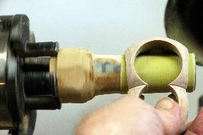 | 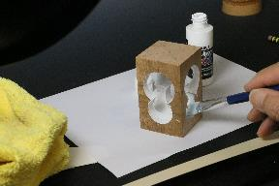
Also, if you plan to paint the inside surfaces, do it now (photo 9).
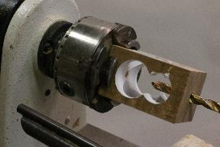 | 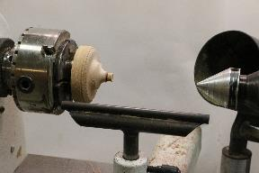
Drill a 3/8” hole through the end of the blank for the finials (photo 10). Remove the blank from the chuck and replace it with a jam chuck with a 3/8” tenon in the center (photo 11).
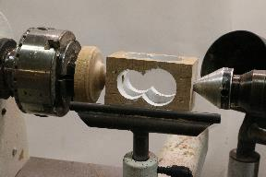 | 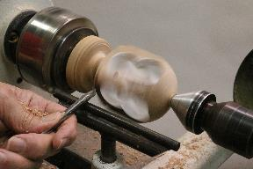
Secure it with the tail stock (photo 12) and shape the outside of the ornament. I use a 3/8” spindle gouge. The shadow of the holes on the inside makes it easy to see where to cut (photo 13).
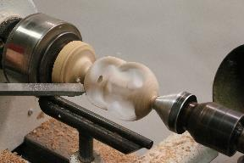 | 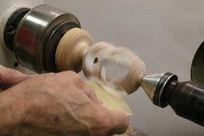

A negative rake scraper can be used to smooth out tool marks from the spindle gouge(photo 14). Sand the outside using a foam pad under the sandpaper while the lathe is on a moderate speed (photo 15).
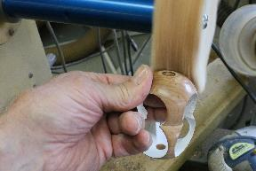 | 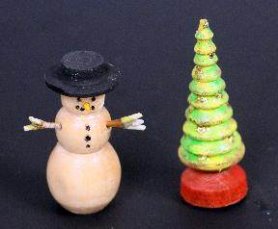
A finish can be applied off the lathe. I use a spray can lacquer and buff the outside with a Beall system buffer (photo 16. If you are going to insert an object in the center (like a turned Christmas tree, snowman, or a bird) do it now. (photo 17)

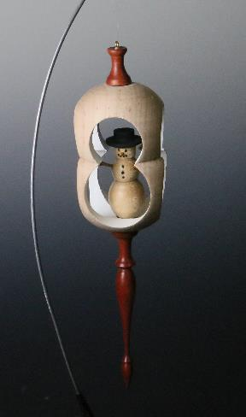
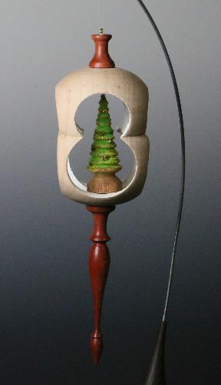
( Photos 18 and 19) Add the finials and an eye hook and you are finished.

Turning finials for ornaments
Walt Wager

Making Finials People are amazed when they see finely turned finials, and they really aren’t all that difficult to do. Here’s how I do it.  First, if this is one of your first tries at a finial, use a model or picture that you want to duplicate. A simple shape, like the one on the right, is a good place to start. (Photo F1a) | 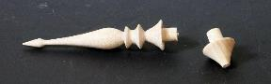
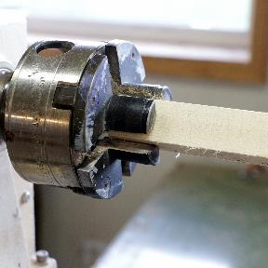 Start with a blank about 6” long and ¾ to 1” square. I secure with “spigot” jaws in my chuck. I don’t use the tail stock for finials. (photo F1b) | 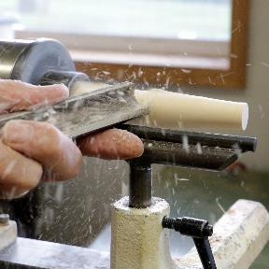  Using a spindle roughing gouge, taper the blank from the Headstock to the end.  Hardwoods work best, here I am using maple. (photo F2)
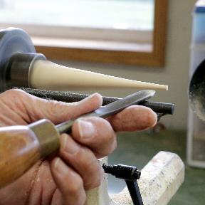  Leave about 1/8” thickness at the end. (photo f3) | 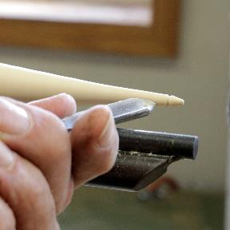  Using a 3/8” spindle gouge, start shaping the end.  (photo f4)
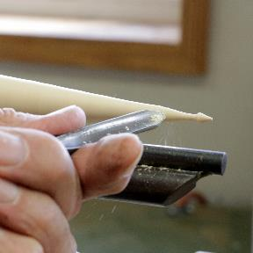  Work your way back towards the headstock, cutting downhill (with the grain). (photo f5) | 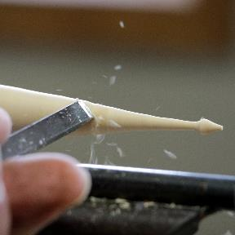  A small skew also works well here – put the bevel on the wood BEFORE picking up the cut, and keep the bevel on the wood throughout the cut. (photo f6)
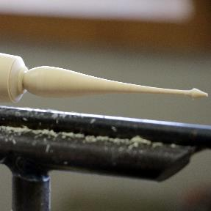  Unless you are really good with the skew, finish the backside of the onion shaped portion using the spindle gouge. (photo f7) | 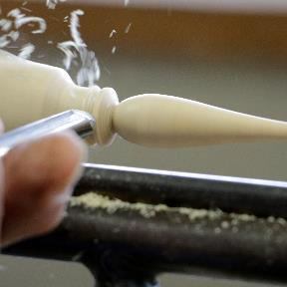  Using the 3/8 spindle gouge, continue shaping the finial working toward the headstock; always cutting downhill (with the grain). (photo f8)
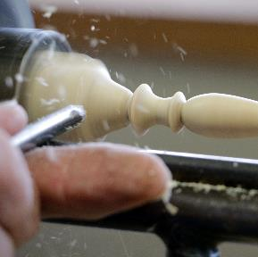  Almost finished, shape the part that will tansition to the tenon on the end. (photo f9) | 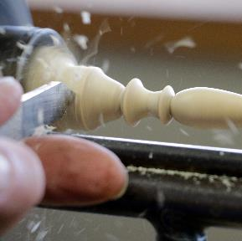  Using a parting tool, cut the end of the finial down to a 3/8” tenon (photo f10)
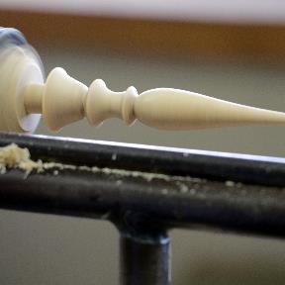  With the tenon finished, sand and apply a finish of your choice. (photo f11) | 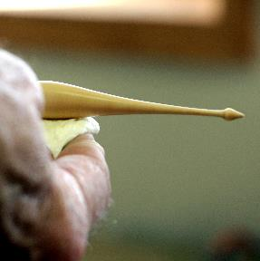  I like to use a friction finish while the finial is still on the lathe because it is fast, and I can see the final result. (photo f12)
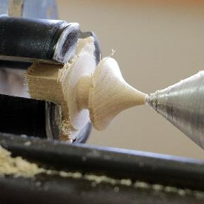  Using the stub that was left in the spigot jaws, make a finial for the top of the globe form. Illustrated here is a simple cone, with the 3/8” tenon. Notice I have the piece supported with the live center because it is so short. (photo f13). | I like to make the body of the ornament and the finials in contrasting colors. The maple finial shown here can be ebonized with india ink, and then finished with polyurethane or lacquer.  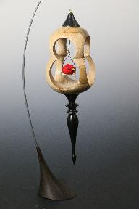  Photo f 14

