Purse Box Handout
A purse box is a tubular box that a woman can use to secure small objects from getting lost in her purse. Others have suggested other materials that might be kept in the box. The purse box is fun to turn and decorate, and simple enough for a beginner to master. It is essentially a tube within a tube. | 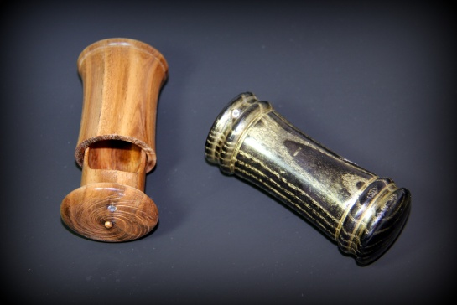
Start with a spindle blank approximately 2 x 2 x 7, between centers. Rough it to round and put a tenon on the tail-stock end of the blank | 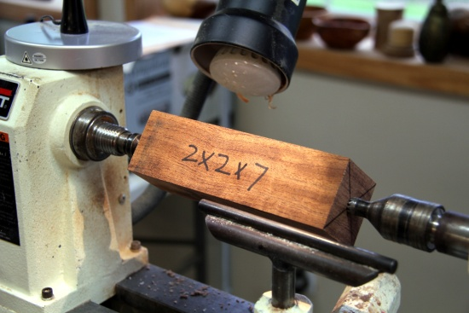
Reverse the blank securing the tenon in a scroll chuck. First, you are going to make the inside tube of the box. Using a 1" or 1 1/16 forsner bit drill a hole 2.25 inches deep. This hole is the inside of the inside tube. | 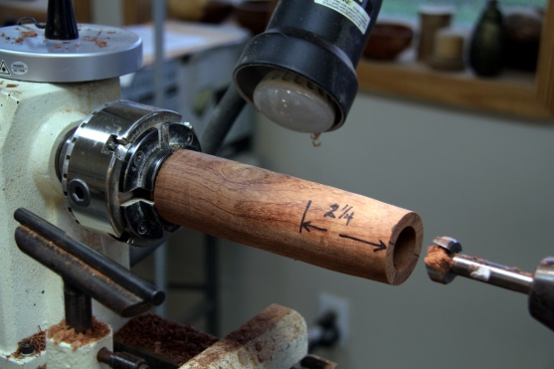
Next mark the outside diameter of the inside tube with a 1 3/16 inch forstner bit. This is a very shallow cut, just enough to provide a guide for turning the outside edge of the tube. | 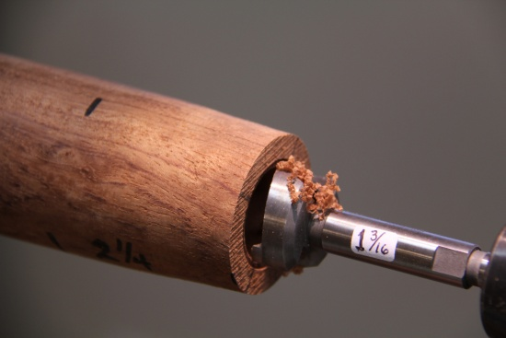
Make a gauge from a piece of scrap by drilling a  1 3/16 inch hole through it. This can be used as you turn the outside diameter of the inside tube. Remember that this tube has to slide into the outter tube, which will have an inside diameter of 1 3/16". The length of the narrow tube is the depth of the hole, about 2.25" | 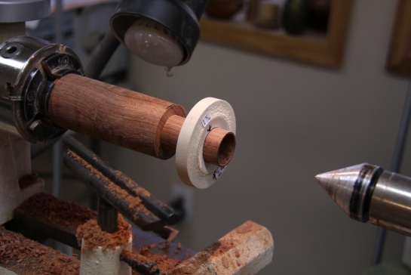
Now is a good time to sand the inside and outside of the inner tube. Make a sanding mandrill from a dowel - DO NOT stick your finger in a spinning tube. | 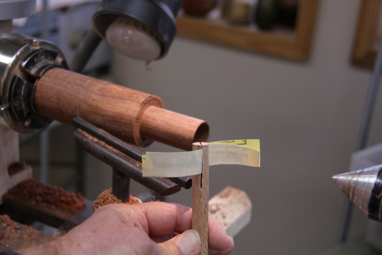
Now turn the top end of the tube - about .50 to .75" long. If you have a design in mind, turn it on the edge of top. You will have time to refine this later.  Part off the top | 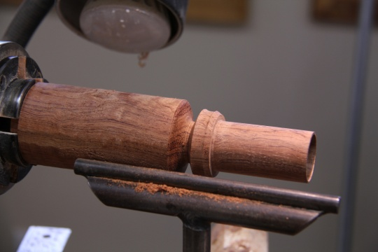
Now using the 1 3/16 fostner bit drill a 2.25" deep hole in the remaining part of the blank. This is the inside of the outer tube. | 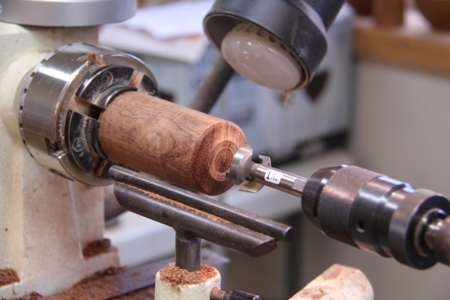
Test to see that the inner tube slides into the outer tube, and that it goes all the way so the top surfaces are flush | 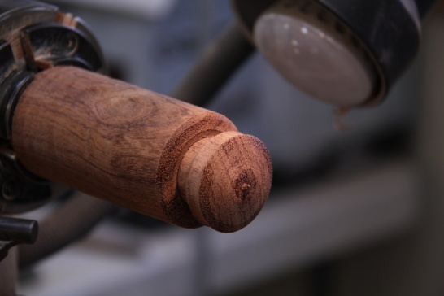
Turn the outer surface of the tube, making the top and bottom symmetrical if you wish. The inside tube can be made tight in the tube by using a piece of tissue or paper towel, so that the outside tube acts like a jam chuck. This allows the finishing of the top closest to the tail stock. Refine the design and part off the outer tube from the stub in the chuck | 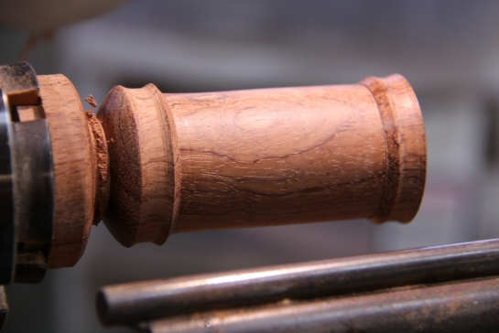
The inside tube needs an end to close it off. Make a small 3/16 to 1/4 tenon on the stub left in the chuck | 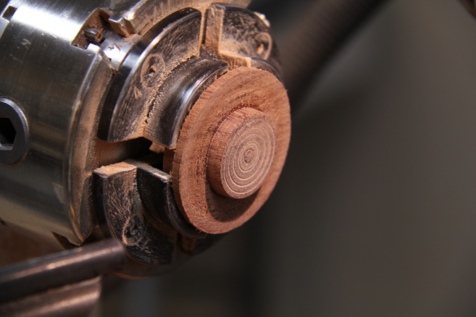
Glue the inner tube onto the tenon, and when it is completely dry, part it off. | 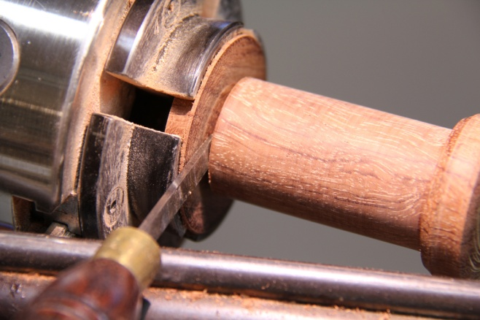
So now you have a closed tube | 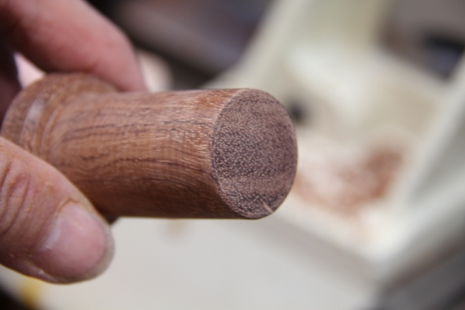
Open the tube by sanding the side with a drum sander in the drill press | 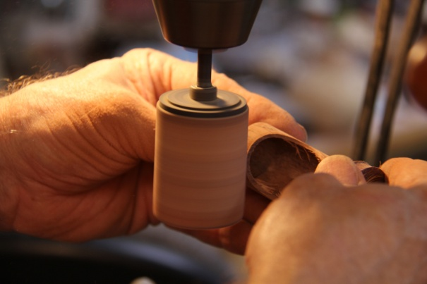
Drill a 5/16" hole for the magnet in the bottom of the inner tube. Careful here, you don't want to go through the bottom. | 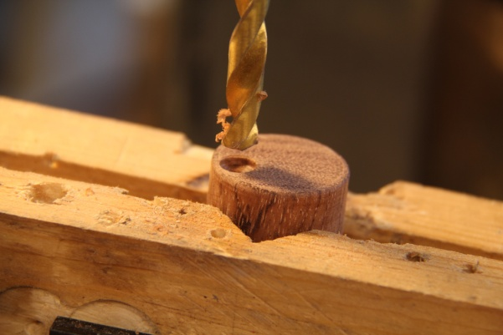
Determine how you want the grain to line up. I mark where I want the magnet in the outer tube with a piece of blue tape. Drill a hole in the bottom of the outer tube for the other magnet. Glue the magnets into the holes being careful to get the polarity correct so the magnets attract each other. I use thin super glue to secure the magnets. | 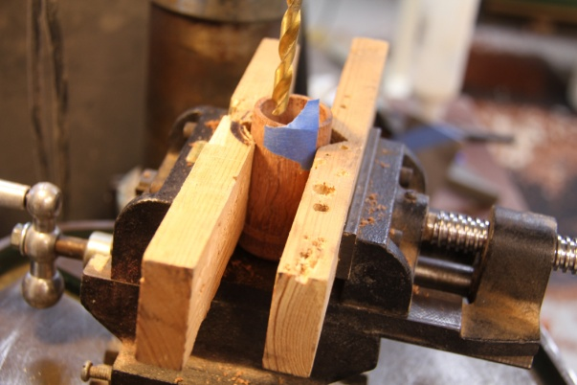
It is important to identify the top of the inner box so the contents don't dump out when it is opened. In this example, a small crystal is being glued into a small hole marking the top of the tube. | 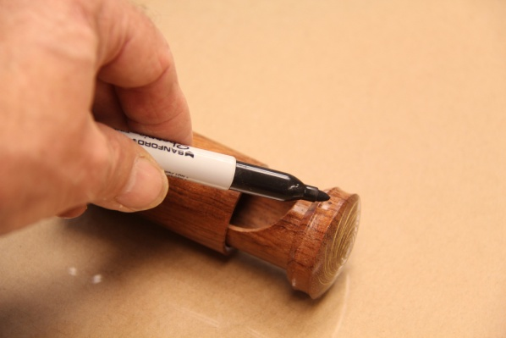
The completed box. It took me longer to write this handout than to turn an actual box! | 