Start with a 2" thick blank approximately 3 to 3.5" in diameter. Between centers --  Rough it to round using a bowl or spindle gouge, and put a 1/4 deep tenon on the tail stock end. It is important to make this tenon large enough so that it can be re-cut later when remounting the base off center. For instance if you have a 2" chuck make the tenon at least 2.5 | 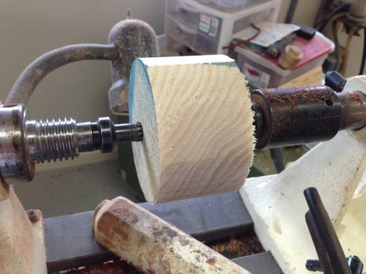
Remove the blank from between centers and Remount it into a scroll chuck --  Finish off the outside edge of the blank and make it smooth. If you are going to make a design on the outside (like beads or coves)this is a good time to do it. --  Finish the face of the blank and sand the surface. Again if you are going to embellish the top of the salt safe, this is a good time to do it | 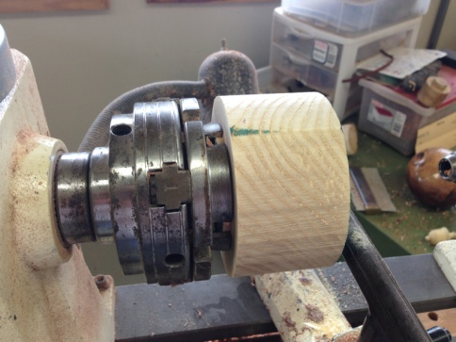
Mark off the top about 1/4 from the face and using a 1/16 or 1/8 parting tool part off the top.  (A tip here is that if you part in about half way, you can use a hand saw to cut the top off the rest of the way.) You want the top to be relatively thin and light so that it isn't too heavy for the magnets to hold when it is swung open. | 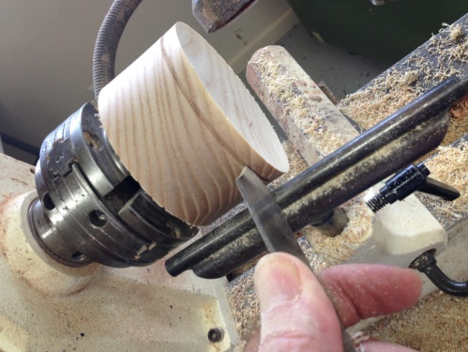
After the top has been parted off, remove the bottom from the chuck and again put it between centers, BUT, this time put it about 1/8 to 3/16" off center, and re-turn the tenon. (This is why you made the original tenon oversize. | 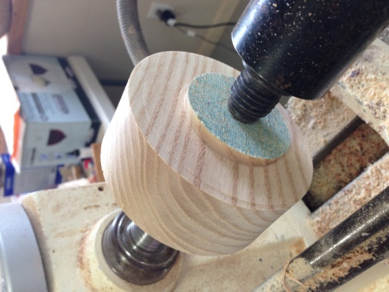
Remount the bottom in the scroll chuck and it will be off center. Make a pencil line around the top to see where the edges will be. Leave enough room for the magnet on the wider edge. | 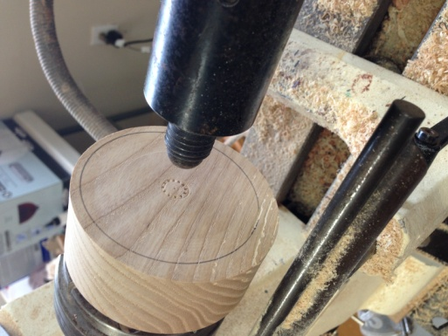
Before hollowing out the inside of the salt safe, I drill a hole, using a 1" forstner bit. Put a piece of tape on the forstner bit to mark the depth of the bottom. Working from the center out hollow out the interior of the box. I use a bedan for this, but a small 1/2 scraper will work just as well. | 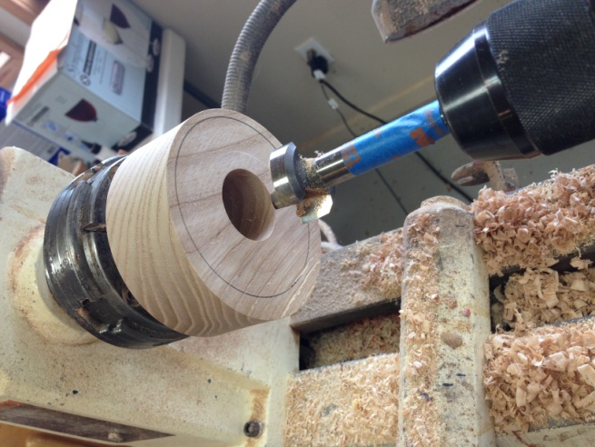
Finish sanding the inside of the box, true up the top edge if necessary  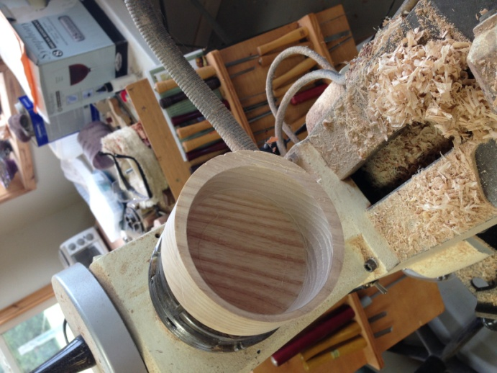 | Remove from the scroll chuck. Make a jam chuck out of a scrap of wood turn off the tenon and finish the bottom.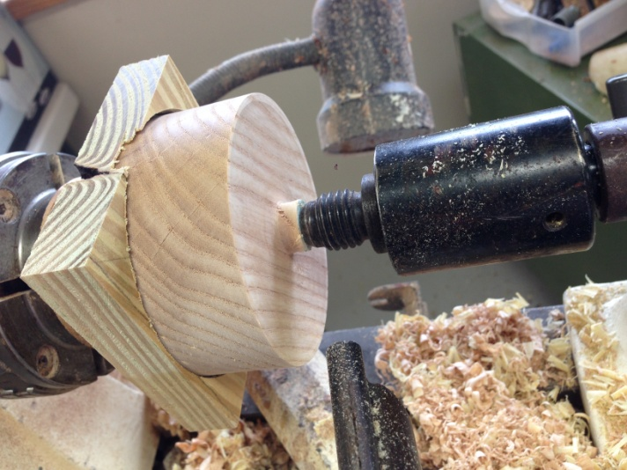
Drill holes for the magnets. I use 1/8 thick x 5/16" diameter magnets that I get from Harbor Freight. However, you can also find them on the internet. I use thin super glue to cement the magnets in place. 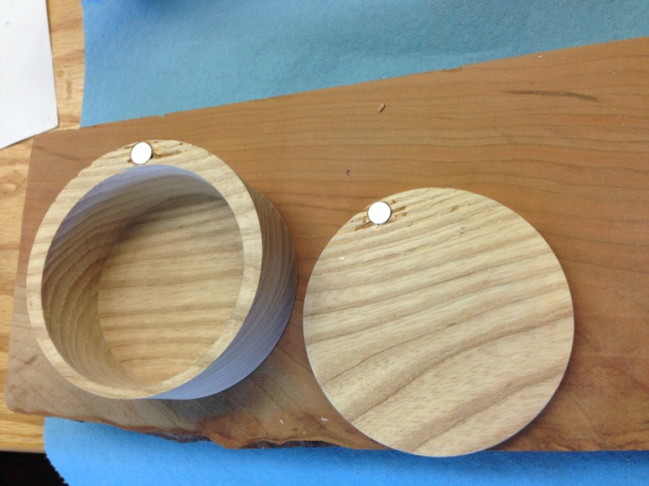 | A coat of walnut oil and the job is done.  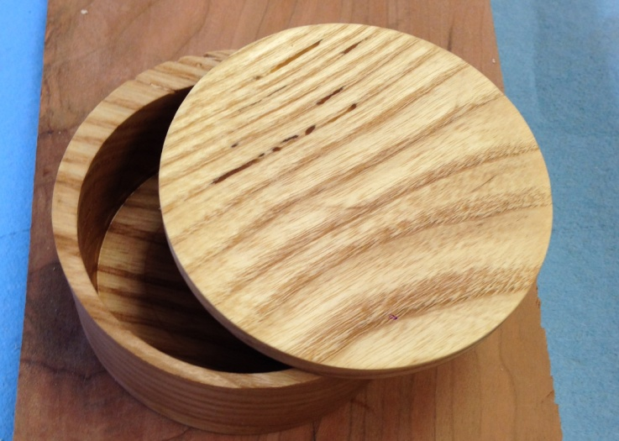
tools needed: spur drive, live center, scroll chuck, bedan or 1/2" square scraper, 3/8 spindle or bowl gouge, tail stock drill chuck, 1" forstner bit, 5/16" twist drill, drill press, thin superglue, 2 small rare-earth magnets. scrap wood for jam chuck.

