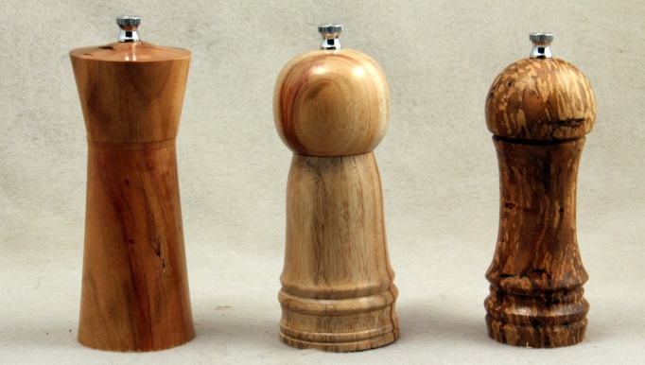

Learn to Turn - Pepper Mills

Instructions for a 6" Pepper Mill kit.

|  |  |
| --- | --- |
| Step 1 - secure 7" long x 2.75" square blank between centers - rough to round |  |
| Step 2 - Turn 2, two inch tenons (#1 and #3) for the scroll chuck (you will turn tenon #2 later) | tenon #3  2"  tenon #1 |
| Step 3 - Measure and mark with a pencil the mill head, and a 5/8" spigot. I suggest a 1 3/4" to 2" mill head. Use a caliper or home-made spigot gauge to make spigot slightly larger than 1 1/16". You will size it accurately later.  Step 4 - Turn tenon #2 on mill body (this should be a 2" tenon). | diagram 1.jpeg  tenon #2 |
| Step 5 - remove the whole thing from between centers, turn it around, and secure tenon #3 in the scroll chuck. Part off the mill head at the end of the 1-1/16 tenon using a 1/8 inch parting tool or hand saw. | diagram 1.jpeg  chuck |
| Step 6 - Drill a 1 1/16 hole with fostner bit half-way way through Mill body. | diagram 2.jpeg Scroll  scroll chuck  jaws  mill body  1 & 1/16 forstner bit |
| Step 7 - Turn the Mill body around in the chuck (tenon #2 in the chuck) remove (turn off) the tenon #3, and drill a 1 5/8 inch hole 1/2" deep with fostner bit . | diagram 2.jpeg  1 5/16 fostner bit  part off tenon #3 |
| Step 8 - Drill the 1 1/16 inch hole the rest of the way through the mill body. | diagram 2.jpeg  1 1/16 fostner bit |
| Step 9 - Remove the mill body from the chuck and re-chuck the Mill Head. Size the tenon so that it fits into the 1 1/16 hole in the body. Drill a 9/32 hole through the Mill head for the pepper mill shaft.  Remove Mill head from scroll chuck. | Size the tenon so that it fits into the 1 1/16 hole in the body.  chuck  diagram 2.jpegdiagram 2.jpeg |
| Step 10 - test fit the pepper mill assembly of the peppermill to see where the center of the shaft comes up to to on the top.  Drop the spring retainer into the 1 5/8 inch hole.  Push in the female grinder matching slots to spring retainer  Drop the Male grinder (large side down) onto the shaft  drop spring (small side down) onto the top of the male grinder  insert shaft from the bottom and through the 9/32 hole in the top.  One half of the screw top should be above the top. Make a pencil mark on the top where it will have to be cut off. | diagram 4.jpeg  shaft  drive plate  spring  grinder retainer  male grinder  female grinder  spring retainer |
| Step 11 - Make a jam chuck to fit into the 1 5/8" recess in the base of the pepper mill,  put the mill top on the mill body and secure between centers. | diagram 3.jpeg  jam chuck on scroll chuck or face plate |
| Step 11 - Turn the pepper mill to the desired shape and length depending upon where the test assembly told you the top should be.  Step 12 - sand and finish  Step 13 - Assemble the pepper mill  A. screw small round drive disk (with square hole) onto the tenon (predrill holes if necessary)  B. Assemble as in test fit  C. screw in grinder retainer into the bottom 1 5/8" hole (pre-drill hoes if necessary). | |
| Credits - Craft Supplies USA The Woodturner's Catalog, for Pepper Mill diagrams from their handout used with permission. | |